# **Analysis of Bitcoin Price Trends and Technical Indicators**

In the last 10 years, Bitcoin, the most popular cryptocurrency worldwide, has attracted a lot of interest. I used historical data and several technical indicators to examine the price behavior of Bitcoin over the previous eight years and provide my findings in this paper. Learning more about the price patterns, volatility, and trading possibilities of Bitcoin is my main objective.

## **1. Relationship between Bitcoin's Closing Price and Trading Volume:**

I began by examining the relationship between Bitcoin's closing price and trading volume. My analysis revealed fluctuations in trading volume alongside changes in the closing price. Notably, periods of high trading volume often coincided with significant price movements, suggesting a correlation between trading activity and price volatility. Analyzing volume spikes relative to historical averages can provide insights into periods of heightened market activity, indicating potential institutional or whale involvement.

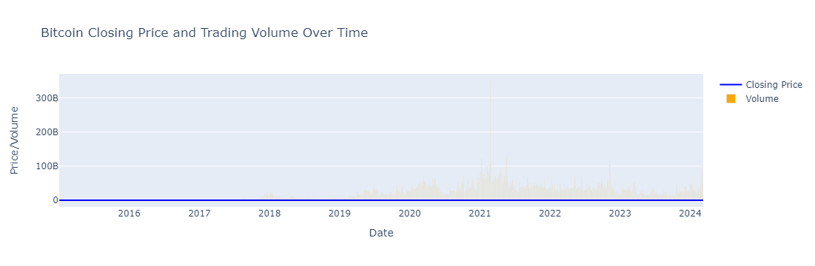

## **2. Exponential Moving Averages (EMAs) for Bitcoin's Closing Price:**

I calculated the 20-day and 50-day Exponential Moving Averages (EMAs) for Bitcoin's closing price. Plotting these EMAs alongside the actual closing prices allowed me to identify trends and potential buy or sell signals. The crossover of the shorter-term EMA (20-day) above or below the longer-term EMA (50-day) indicated momentum shifts and potential trading opportunities. Utilizing an "EMA ribbon" analysis, which involves plotting multiple EMAs of varying lengths on the same chart, provides a comprehensive view of trend strength and direction.

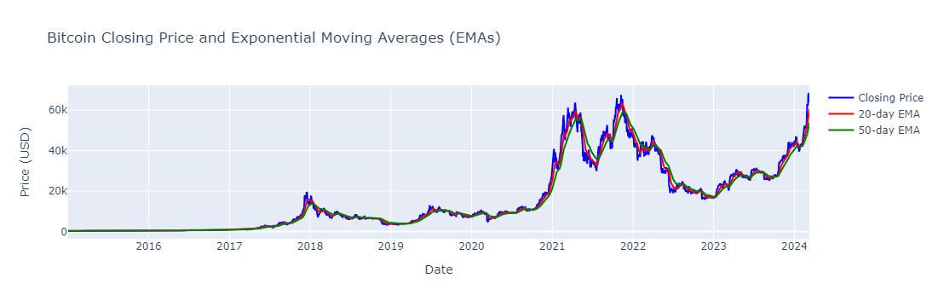

## **3. Identification of MACD Line and Signal Line Crosses:**

Using the Moving Average Convergence Divergence (MACD) indicator, I identified instances where the MACD line crossed above or below the signal line. These crossovers often signaled changes in trend direction, providing insights into potential entry or exit points for traders. Analyzing the MACD histogram can offer further confirmation of trend changes, with histogram bars above or below the zero line indicating bullish or bearish momentum, respectively.

## **4. Assessment of Bitcoin's Price Volatility using Average True Range (ATR):**

I analyzed Bitcoin's price volatility using the Average True Range (ATR) indicator. The ATR provided a measure of price volatility over time, allowing me to gauge the magnitude of price movements. Higher ATR values indicated increased volatility, which could present both opportunities and risks for traders. Incorporating historical volatility analysis using ATR percentiles can help traders identify periods of extreme volatility relative to historical norms, enabling more effective risk management strategies.

## **5. Detection of Significant Deviations in Bitcoin's Closing Price from its Simple Moving Average (SMA):**

By comparing Bitcoin's closing price to its 50-day Simple Moving Average (SMA), I identified significant deviations that could signal potential trend reversals or continuation patterns. These deviations, coupled with the calculation of standard deviation bands around the SMA, provided valuable insights for traders seeking to capitalize on price movements. Utilizing dynamic support and resistance levels derived from SMA analysis, combined with other technical indicators such as Fibonacci retracements or pivot points, can enhance the accuracy of price level identification and improve trading decision-making.

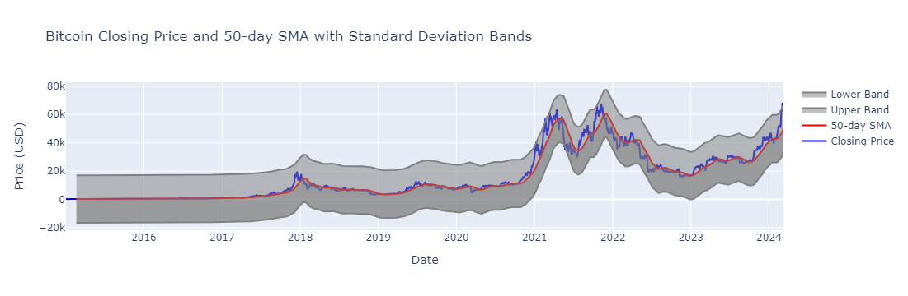

In conclusion, our analysis of Bitcoin's price trends and technical indicators revealed valuable insights for traders and investors. By understanding the relationship between price movements, trading volume, and various technical indicators, stakeholders can make more informed decisions in the dynamic cryptocurrency market. However, it's essential to exercise caution and conduct thorough risk management strategies when trading cryptocurrencies due to their inherent volatility.

### **Recommendations:**

My analysis leads me to suggest that traders and investors watch important technical indicators like EMAs, MACD, ATR, and SMA attentively to spot possible trades and efficiently manage risk. On top of that, keeping up with market news and happenings can offer an insightful background for deciphering price changes and making wise choices.

### **Disclaimer:**

This report is for informational purposes only and should not be construed as financial advice. Trading cryptocurrencies involves inherent risks, and individuals should conduct their own research and consult with financial professionals before making any investment decisions.

